ABSTRACT

Big Data is an emerging growing dataset beyond the ability of a traditional database tool. Hadoop rides the big data where the massive quantity of information is processed using cluster of commodity hardware. Web server logs are semi-structured files generated by the computer in large volume usually of flat text files. It is utilized efficiently by Mapreduce as it process one line at a time. This project performs the session identification in log files using Hadoop in a distributed cluster. Apache Hadoop Mapreduce a data processing platform is used in pseudo distributed mode and in fully distributed mode. The framework effectively identifies the session utilized by the web surfer to recognize the unique users and pages accessed by the users. The identified session is analyzed in R to produce a statistical report based on total count of visit per day. The results are compared with non-hadoop approach a java environment, and it results in a better time efficiency, storage and processing speed of the proposed work.

1. Introduction

A data is a collection of facts from the grids of web servers usually of unorganized form in the digital universe. Around 90% of data present in today’s world are generated in last two years. A large amount of the data available in the internet is generated either by individuals, groups or by the organization over a particular period of time. The volume of data becomes larger day by day as the usage of World Wide Web makes an interdisciplinary part of human activities. Rise of these data leads to a new technology such as big data that acts as a tool to process, manipulate and manage very large dataset along with the storage required.
Big Data is a high volume, high velocity and high variety information assets that demand cost-effective , innovative forums of information processing for enhanced insight and decision making. Big data, a buzz word in the business intelligence can handle petabytes or terabytes of data in a reasonable amount of time. Big data is distinct from large existing database which uses Hadoop framework for data intensive distributed applications.
Big Data analytics applies advanced analytical techniques of large datasets to discover hidden patterns and other useful information. It is performed using software tools mainly for predictive analysis and data mining. The growing number of technologies is used to aggregate, manipulate, manage and analyze big data. Some of the most prominent technologies are [3] NoSQL databases that include Cassandra, MongoDb, redis, Hbase and Hadoop framework includes Hadoop, HDFS, Hive, Pig.
Data can come from a variety of sources and in a variety of types that includes not only structured traditional relational data, but also semi-structured and unstructured data. Machine generated data such as click stream logs and email logs of unstructured data are larger in magnitude when compared with human generated data that cannot fit in a traditional data warehouses for further analysis.

1.1 Literary Survey

Numerous research works are carried out in web log mining, hadoop and some of them are reviewed below. Murat proposed the smart miner framework that extracts the user behavior from web logs. The framework used the smart session construction to trace the frequent user access paths. Sayalee Narkhede introduced the Hadoop-MR log file analysis tool that provides a statistical report on total hits of a web page, user activity, traffic sources. This work was performed in two machines with three instances of hadoop by distributing the log files evenly to all nodes.
Milind Bhandare put forth a generic log analyzer framework for different kinds of log files such as a database or file system. The work was implemented as a distributed query processing to minimize the response time for the users which can be extendable for some format of logs. Parallelization of Genetic Algorithm (PGA) was suggested by Kanchan Sharadchandra Rahate. PGA uses OlexGA package for classifying the document. The train model data is stored in HDFS and the test model categories the text document.
A framework for unstructured data analysis was proposed by Das using big data of public tweets from twitter. The tweets are stored in Hbase using Hadoop cluster through Rest Calls and text mining algorithms are processed for data analysis.
The semi structured log files are large datasets which are challenging to store, search, share, visualize and analyze. Almost 26% of web log types of data require big data technology to perform an analysis. In order to improve the usage of a website and to track the user behavior, in online advertising and E-commerce the web log mining is performed using Hadoop.
The related works so far stated above performs the work with good scalability but fails to experiment the time efficiency between the different modes of hadoop and necessity of the scalability. The proposed work analyses the working of both hadoop modes and the time efficiency in each mode specifically for semi structure log data, along which a statistical report is made.
This project effectively utilizes the web logs of NASA website accessed by the user, to identify the session using Apache Hadoop Mapreduce in a distributed cluster. As hadoop does not enforce schema based storage, it processes the semi structured log files easily. The file holds 550MB dataset collected from various time period of the same year, and is stored in HDFS which is scattered in the cluster as blocks through high speed network. The work encompasses the use of both the modes along with non-hadoop approach. The identified session is analyzed based on date and number of times visited using R tool.

2. Software Requirements Specification

2.1 Functional Requirement:
- User must provide web server log file as input to process.
  - Log File should be in the form of general web server log format.
  - Log file should be of Text format.
  - Size of log file should not exceed available size on hadoop cluster.

- Process the log file using map-reduce algorithm.
- 2.1 Map-Reduce algorithm must contain mapper, reducer and partitioner.
3. Map-Reduce algorithm should be run on Hadoop cluster
- 3.1. Hadoop multi node cluster need to be set up.
- 3.2 Hadoop cluster must contain atleast 2 slave nodes.
4. Provide User Interface
- 4.1 Provide web user interface.
- 4.2 User must be able access the hadoop filesystem in order to load and retrive the data
5. Convert IP address into latitudes and longitudes
- Convert the processed log file's ip addreess's into latitudes and longitudes.
6. Generate visual reports
- Reports need to be generated using R language.
- Output generated from map-reduce algorithm need to be visualized using line graphs, bar graphs etc.
- Latitudes and longitudes generated in the previous steps must be plotted on map.

2.2 Non Functional Requirements:

Performance: Performance of the application is dependent on the surroundings of user. As the accuracy of the execution is dependent on the proper command uttered in a not so noisy environment. Application is productive if it is working in noise free environment.

Availability: Always available with this application installed on a PC / Laptop.

Maintainability: Easily maintained with minimum knowledge of using a computer.

2.3 Computer Requirements:

- Apache Hadoop 1.2.1
- Ubuntu OS
- 3 Computers with 4 GB RAM
- Intel Core 2 Duo Processor and above

- Design

3.1 Use Case Diagram
A use case diagram at its simplest is a representation of a user's interaction with the system that shows the relationship between the user and the different use cases in which the user is involved. A use case diagram can identify the different types of users of a system and the different use cases and will often be accompanied by other types of diagrams as well.
The above use case diagram explains the actors and the use cases of the system. The only actor in the design is the analyst who performs two operations.The analyst loads the log file into the system and performs log analysis using MapReduce. The other operation performed by the analyst is generating statistical reports.
3.2 Class Diagram
A class diagram in the Unified Modeling Language (UML) is a type of static structure diagram that describes the structure of a system by showing the system's classes, their attributes, operations (or methods), and the relationships among objects.
3.2.1 MapReduce class diagram
The below class diagram gives us a clear idea of all the classes in the software and also their operations.

3.2.2 GeoConverter class diagram

The above class diagram explains the classes involved in the geo-conversion of the IP addresses. The LookUpProgram class contains the main method.
3.3 Sequence Diagram:
A Sequence diagram is an Interaction Diagram that shows how processes operate with one another and what is their order. It is a construct of a Message Sequence Chart A sequence diagram shows object interactions arranged in time sequence. It depicts the objects and classes involved in the scenario and the sequence of messages exchanged between the objects needed to carry out the functionality of the scenario.
3.3.1 MapReduce Sequence Diagram

The above sequence diagram explains the sequence in which processes operate during the MapReduce execution.

4. IMPLEMENTATION
4.1 MapReduce
MapReduce is a simple programming model for processing huge data sets in parallel. The basic notion of MapReduce is to divide a task into subtasks, handle the sub-tasks in parallel, and aggregate the results of the subtasks to form the final output. Programs written in MapReduce are automatically parallelized: programmers do not need to be concerned about the implementation details of parallel processing. Instead, programmers write two functions: map and reduce. The map phase reads the input (in parallel) and distributes the data to the reducers. Auxiliary phases such as sorting, partitioning and combining values can also take place between the map and reduce phases.
MapReduce programs are generally used to process large files. The input and output for the map and reduce functions are expressed in the form of key-value pairs.
A Hadoop MapReduce program also has a component called the Driver. The driver is responsible for initializing the job with its configuration details, specifying the mapper and the reducer classes for the job, informing the Hadoop platform to execute the code on the specified input file(s) and controlling the location where the output files are placed.
    - Driver
The driver class is responsible for configuring the jobs in MapReduce.The number of mappers, reducers and also the mapper, reducer and the partitioner classes are set by the driver class. The job name is also specified in the driver class.In addition the paths for input and output of files to and from MapReduce are set in the driver class.

public class LogDriver {
public static void main(String[] args) throws Exception {
Job job = new Job();
job.setJarByClass(LogDriver.class);
job.setJobName("Log Analyzer");
job.setMapperClass(LogMapper.class);
job.setPartitionerClass(LogPartitioner.class);
job.setPartitionerClass(LogPartitioner.class);
job.setReducerClass(LogReducer.class);
job.setNumReduceTasks(2);
job.setOutputKeyClass(IntWritable.class);
job.setOutputValueClass(IntWritable.class);
FileInputFormat.addInputPath(job, new Path(args[0]));
FileOutputFormat.setOutputPath(job, new Path(args[1]));
job.waitForCompletion(true);
}
}

4.1.2 Mappper
A Mapper maps input key/value pairs to a set of intermediate key/value pairs.
Maps are the individual tasks which transform input records into a intermediate records. The transformed intermediate records need not be of the same type as the input records. A given input pair may map to zero or many output pairs.
The Hadoop Map-Reduce framework spawns one map task for each InputSplits generated by the InputFormat for the job. Mapper implementations can access the Configuration for the job via the JobContext.getConfiguration().
The framework first calls setup(org.apache.hadoop.mapreduce.Mapper.Context), followed by map(Object, Object, Context) for each key/value pair in the InputSplit. Finally cleanup(Context) is called.
All intermediate values associated with a given output key are subsequently grouped by the framework, and passed to a Reducer to determine the final output. Users can control the sorting and grouping by specifying two key RawComparator classes.
The Mapper outputs are partitioned per Reducer. Users can control which keys (and hence records) go to which Reducer by implementing a custom Partitioner.
Users can optionally specify a combiner, via Job.setCombinerClass(Class), to perform local aggregation of the intermediate outputs, which helps to cut down the amount of data transferred from the Mapper to the Reducer.
Applications can specify if and how the intermediate outputs are to be compressed and which CompressionCodecs are to be used via the Configuration.
If the job has zero reduces then the output of the Mapper is directly written to the OutputFormat without sorting by keys.
public class LogMapper extends
Mapper<LongWritable, Text, IntWritable, IntWritable>
{
private static Logger logger = LoggerFactory.getLogger(LogMapper.class);
private IntWritable hour = new IntWritable();
//private Text hour = new Text();
private final static IntWritable one = new IntWritable(1);
private static Pattern logPattern = Pattern
.compile("([^ ]*) ([^ ]*) ([^ ]*) \\[([^]]*)\\]"
+ " \"([^\"]*)\""
+ " ([^ ]*) ([^ ]*).*");

public void map(LongWritable key, Text value, Context context)
throws InterruptedException, IOException {
logger.info("Mapper started");
String line = ((Text) value).toString();
Matcher matcher = logPattern.matcher(line);
if (matcher.matches()) {
String timestamp = matcher.group(4);
//String ipAdd = matcher.group(1);
try {
hour.set(ParseLog.getHour(timestamp));
//hour.set(ipAdd);
} catch (ParseException e) {
logger.warn("Exception", e);
}
context.write(hour, one);
}
logger.info("Mapper Completed");
}
}
An example of log record is 125.125.125.125 - uche [20/Jul/2008:12:30:45 +0700] "GET /index.html HTTP/1.1" 200 2345

Fields in a common log format line
Field name | Example value | Description
host | 125.125.125.125 | IP address or host name of the HTTP client that made the request
identd | - | Authentication Server Protocol (RFC 931) identifier for the client; this field is rarely used. If unused it's given as "-".
username | uche | HTTP authenticated user name (via 401 response handshake); this is the login and password dialog you see on some sites, as opposed to a login form embedded in a Web page, where your ID information is stored in a server-side session. If unused (for example, when the request is for an unrestricted resource) it's given as "-".
date/time | [20/Jul/2008:12:30:45 +0700] | Date then time then timezone, in the format [dd/MMM/yyyy:hh:mm:ss +-hhmm]
request line | "GET /index.html HTTP/1.1" | The leading line of the HTTP request, which includes the method ("GET"), the requested resource, and the HTTP protocol version
status code | 200 | Numeric code used in the response to indicating the disposition of the request, for example to indicate success, failure, redirect, or authentication requirement
bytes |  | Number of bytes transferred in the body of the response

The log file can be parsed using a regular expression.
private static Pattern logPattern = Pattern
.compile("([^ ]*) ([^ ]*) ([^ ]*) \\[([^]]*)\\]"
+ " \"([^\"]*)\""
+ " ([^ ]*) ([^ ]*).*");
The Matcher class can be used to extract the required field from the log record.
Compilation of the Pattern logPattern divides the fields of the record into groups. The records in the log file are parsed and only the values of the required group are extracted.

4.1.3 ParseLog
The ParseLog class takes the timestamp from the LogMapper class as a parameter and compares the parameter with an object of SimpleDateFormat. The getHours(),getDay(),getDate() methods of the Date class can be used to extract the hour, day and date from the timestamp respectively, and are returned by the getHour() method of the ParseLog class.
public class ParseLog {
@SuppressWarnings("deprecation")
public static int getHour(String timestamp) throws ParseException {
System.out.print(timestamp);
SimpleDateFormat simpleDateFormat = new SimpleDateFormat("dd/MMM/yyyy:HH:mm:ss");
Date mydate = simpleDateFormat.parse(timestamp);
return mydate.getHours();

}

}
4.1.4 Reducer
A Reducer reduces a set of intermediate values which share a key to a smaller set of values.
Reducer implementations can access the Configuration for the job via the JobContext.getConfiguration() method.
Reducer has 3 primary phases:

Shuffle
The Reducer copies the sorted output from each Mapper using HTTP across the network.

Sort
The framework merge sorts Reducer inputs by keys (since different Mappers may have output the same key).
The shuffle and sort phases occur simultaneously i.e. while outputs are being fetched they are merged.

SecondarySort
To achieve a secondary sort on the values returned by the value iterator, the application should extend the key with the secondary key and define a grouping comparator. The keys will be sorted using the entire key, but will be grouped using the grouping comparator to decide which keys and values are sent in the same call to reduce.The grouping comparator is specified via Job.setGroupingComparatorClass(Class). The sort order is controlled by Job.setSortComparatorClass(Class).
For example, say that you want to find duplicate web pages and tag them all with the url of the "best" known example. You would set up the job like:
  - Map Input Key: url
  - Map Input Value: document
  - Map Output Key: document checksum, url pagerank
  - Map Output Value: url
  - Partitioner: by checksum
  - OutputKeyComparator: by checksum and then decreasing pagerank
  - OutputValueGroupingComparator: by checksum

Reduce
In this phase the reduce(Object, Iterable, Context) method is called for each <key, (collection of values)> in the sorted inputs.
The output of the reduce task is typically written to a RecordWriter via TaskInputOutputContext.write(Object, Object).
The output of the Reducer is not re-sorted.
public class LogReducer extends
Reducer<IntWritable, IntWritable, IntWritable, IntWritable> {

private static Logger logger = LoggerFactory.getLogger(LogReducer.class);
public void reduce(IntWritable key, Iterable<IntWritable> values,
Context context) throws IOException, InterruptedException {

logger.info("Reducer started");
int sum = 0;
for (IntWritable value : values) {
sum = sum + value.get();
}
context.write(key, new IntWritable(sum));
logger.info("Reducer completed");
}
}
4.1.5 Partioner
A Partitioner partitions the key space.
Partitioner controls the partitioning of the keys of the intermediate map-outputs. The key (or a subset of the key) is used to derive the partition, typically by a hash function. The total number of partitions is the same as the number of reduce tasks for the job. Hence this controls which of the m reduce tasks the intermediate key (and hence the record) is sent for reduction.
Note: If you require your Partitioner class to obtain the Job's configuration object, implement the Configurable interface.
public class LogPartitioner extends Partitioner<IntWritable, IntWritable> {

private static Logger logger =LoggerFactory.getLogger(LogPartitioner.class);
public int getPartition(IntWritable key, IntWritable value, int numReduceTasks) {
logger.info("Partitioner started");
int intKey=key.get();
if(intKey >= 8 && intKey <= 18){
return 1;
}
else{
return 0;
}
}

}

  - Obtaining the GeoLocation from the requests
The following code snippet explains how the IP addresses resulting from the MapReduce are converted into co-ordinates by accessing a database containing the list of IP addresses, mapped to their latitude, longitude, country, city etc.

try
{
if(loc != null){
return new GeoLocation(loc.countryCode, loc.countryName, loc.postalCode, loc.city, loc.region,
loc.area_code, loc.dma_code, loc.metro_code, loc.latitude, loc.longitude);
}
else{
System.out.println("Invalid");
return new GeoLocation("INVALID","INVALID","INVALID","INVLAID","INVALID",0,0,0,-123456,-123456);
}
}
catch(Exception e)
{
System.out.println(e);
return new GeoLocation("INVALID","INVALID","INVALID","INVLAID","INVALID",0,0,0,-123456,-123456);
}

  - Visualizing the outputs using R
R is a free software environment for statistical computing and graphics. It compiles and runs on a wide variety of UNIX platforms, Windows and MacOS. R is aprogramming language and software environment for statistical computing and graphics. The R language is widely used among statisticians and data miners for developing statistical software and data analysis.Polls, surveys of data miners, and studies of scholarly literature databases show that R's popularity has increased substantially in recent years.

4.3.1 Generating a Line Graph

Hours_requests
The following R script takes the hours and requests as input and generates a line plot with hours on x-axis and requests on y-xis

ggplot(data=hours, aes(x=hours, y=requests,size=1, color=1)) +
geom_line() +
scale_x_continuous( breaks=c(seq(0,23,by=1))) +
expand_limits(x=2) +
geom_point()+
geom_text(aes(label=requests),hjust=0, vjust=0) +
labs(title="Hour-wise traffic distribution throughout the dataset")

Date_requests
The following R script takes the dates and requests as input and generates a line plot with dates on x-axis and requests on y-xis

ggplot(data=dates, aes(x=date, y=requests,size=1, color=1)) +
geom_line() +
scale_x_continuous( breaks=c(seq(0,23,by=1))) +
expand_limits(x=2) +
geom_point()+
geom_text(aes(label=requests),hjust=0, vjust=0) +
labs(title="Date-wise traffic distribution throughout the dataset")

Day_requests
The following R script takes the days and requests as input and generates a line plot with days on x-axis and requests on y-xis

ggplot(data=days, aes(x=day, y=requests,size=1, color=1)) +
geom_line() +
scale_x_continuous( breaks=c(seq(0,23,by=1))) +
expand_limits(x=2) +
geom_point()+
geom_text(aes(label=requests),hjust=0, vjust=0) +
labs(title="Day-wise traffic distribution throughout the dataset")

4.3.2 Plotting co-ordinates on a World Map

The following R script takes the co-ordinates of the geolocation of the IP addresses from which the requests have been generated. The co-ordinates are plotted on a world map, visualising the distribution of traffic to the web-site.

world_map<-map_data("world")
world_map <- subset(world_map, region != "Antarctica")
gg <- ggplot(world_map)

gg<-ggplot(locs, aes(x=longitude,y=latitude))+borders("world", color="grey100", fill="grey93")+geom_point(color="red",size=1)+labs(x="",y="")+theme_bw()+theme(axis.text=element_blank(),axis.ticks=element_blank())+coord_fixed()

gg <- gg + scale_x_continuous(expand=c(0,0))
gg <- gg + scale_y_continuous(expand=c(0,0))
gg <- gg + expand_limits(x = world_map$long, y = world_map$lat)
gg <- gg + ggtitle("The traffic to the web-site")

gg <- gg + theme(axis.text=element_blank(),
axis.title=element_blank(),
legend.position="none",
axis.ticks=element_blank(),
panel.grid=element_blank(),
#panel.background=element_rect(color=NA,fill=NA),
plot.background=element_rect(fill="#ABCDDCBA"))

gg

5. Testing

5.1 Testing the Web Interface

Smoke Testing HDFS
5.1.1 Accessing namenode server using web browser:
Browsing to the Namenode: http://localhost:50070/dfshealth.jsp

Browsing the file system using the web interface: http://localhost:50075/

5.1.2 Accessing secondary namenode using web browser
Browsing the secondary namenode : http://localhost:50090/status.jsp

5.1.3 Accessing the task tracker using web interface:
Browsing the task tracker: http://localhost:50060/tasktracker.jsp

Conclusion:

At present the Big data technology is successfully incorporated for all real domain problems such as web log analysis, fraud detection and text analysis. This paper reveals the importance of one of the Big data technology Hadoop, where the framework handles large amount of data in a cluster for web log mining. Data cleaning, the main part of preprocessing is performed to remove the inconsistent data. The preprocessed data is again manipulated using session identification algorithm to explore the user session. Unique identification of fields is carried out to track the user behavior. Both the algorithms process the NASA web server logs using Mapreduce task. The huge data is stored in HDFS as text files and is accessed around the cluster in blocks. From the results it is observed that the framework developed in hadoop has high performance when compared to the other approaches.

Future Enhancements:

Future work can be extended to number of nodes for prediction analysis to find the next page that will be accessed by the user in a particular website. Also the resulting text files stored in HDFS can be binded with NoSQL databases, and other data mining tools for analysis.

References:

[1] http://www.web-datamining.net/
[2] Ruchi Verma, Sathyan R Mani, “Use of Big Data Tehnologies in Capital Markets,” 2012 Infosys Limited, Bangalore, India.
[3] James Manyika, Brad Brown et.al, “Big Data: The next frontier for Innovation, Competition, and Productivity,” McKinsey Global Institute, June 2011.
[4] Murat Ali , Ismail Hakki Toroslu, “Smart Miner: A New Framework for mining Large Scale Web Usage Data,” WWW 2009, April 20-24. 2009 Madrid, Spain. ACM 978-1-60558-487-4/09/04.
[5] Sayalee Narkhede and Tripti Baraskar, “HMR Log Analyzer: Analyze Web Application Logs Over Hadoop MapReduce,” International Journal of UbiComp (IJU) vol.4, No.3, July 2013.
[6] Milind Bhandare, Vikas Nagare et al., “Generic Log Analyzer Using Hadoop Mapreduce Framework,” International Journal of Emerging Technology and Advanced Engineering (IJETAE), vol.3, issue 9, September 2013.
[7] Kanchan Sharadchandra Rahate et al., “A Novel Technique for Parallelization of Genetic Algorithm using Hadoop,” International Journal of Engineering Trends and Technology (IJETT), vol.4, issue 8, August 2013.
[8] T. K. Das et al., “BIG Data Analytics: A Framework for Unstructured Data Analysis,” International Journal of Engineering and Technology (IJET) vol 5, No 1, Feb-Mar 2013.
[9] Joseph McKendrick, “Big Data, Big Challeneges, Big Opportunities: 2012 IOUG Big Data strategies survey,” September 2012.
[10] Jeffrey Dean and Sanjay Ghemawat, “MapReduce: Simplified Data Processing on Large Clusters,” Google, Inc
[11] “Hadoop”, http://hadoop.apache.org.
[12] Tom White, “Hadoop: The definitive Guide,” Third Edition, ISBN: 978-1-449-31152-0-1327616795.
[13] Ian Mitchell, Mark Locke and Aundy Fuller, “The White Book of Big Data”
[14] Http://en.wikipedia.org/wiki/R (programming language).

Appendix A: Abbreviation

HDFS - Hadoop Distributed File System
MR – Map Reduce
GFS - Google File System
JPS-JVM Process Status Tool
JSON - Java Script Object Notation
NN - NameNode
DN - Data Node
SNN - Secondary NameNode
JT - Job Tracker
TT - Task Tracker
HA NN - Highly Available NameNode (or NN HA - NameNode Highly Available)
REST - Representational State Transfer
HiveQL - Hive SQL
CDH - Cloudera’s Distribution Including Apache Hadoop
ZKFC - ZooKeeper Failover Controller
FUSE - Filesystem In Userspace
YARN - Yet Another Resource Negotiator

Appendix B: Software Installation Process
Step 1: Installing Java
Hadoop requires a working Java 1.5+ (aka Java 5) installation. However, using Java 1.6 (aka Java 6) is recommended for running Hadoop.
1  2  3  4  5  6  7  8  9  10  11  12  13  14  15  16 | # Add the Ferramosca Roberto's repository to your apt repositories  # See https://launchpad.net/~ferramroberto/  #  $ sudo apt-get install python-software-properties  $ sudo add-apt-repository ppa:ferramroberto/java  # Update the source list  $ sudo apt-get update  # Install Sun Java 6 JDK  $ sudo apt-get install sun-java6-jdk  # Select Sun's Java as the default on your machine.  # See 'sudo update-alternatives --config java' for more information.  #  $ sudo update-java-alternatives -s java-6-sun
The full JDK which will be placed in /usr/lib/jvm/java-6-sun
Make a quick check whether JDK is correctly set up:
1  2  3  4 | user@ubuntu:~# java –version  java version "1.6.0_20"  Java(TM) SE Runtime Environment (build 1.6.0_20-b02)  Java HotSpot(TM) Client VM (build 16.3-b01, mixed mode, sharing)

Step 2: Running Hadoop on Ubuntu Linux (Single-Node Cluster)
Hadoop is a framework written in Java for running applications on large clusters of commodity hardware and incorporates features similar to those of the Google File System (GFS) and of the MapReduce computing paradigm. Hadoop’s HDFS is a highly fault-tolerant distributed file system and, like Hadoop in general, designed to be deployed on low-cost hardware. It provides high throughput access to application data and is suitable for applications that have large data sets.

Adding a dedicated Hadoop system user
We will use a dedicated Hadoop user account for running Hadoop. While that’s not required it is recommended because it helps to separate the Hadoop installation from other software applications and user accounts running on the same machine (think: security, permissions, backups, etc).
1  2 | $ sudo addgroup hadoop  $ sudo adduser --ingroup hadoop hduser
This will add the user hduser and the group hadoop to your local machine.
Configuring SSH
Hadoop requires SSH access to manage its nodes, i.e. remote machines plus your local machine if you want to use Hadoop on it (which is what we want to do in this short tutorial). For our single-node setup of Hadoop, we therefore need to configure SSH access to localhost for the hduser user we created in the previous section.
I assume that you have SSH up and running on your machine and configured it to allow SSH public key authentication. If not, there are several online guides available.
First, we have to generate an SSH key for the hduser user.
1  2  3  4  5  6  7  8  9  10  11  12 | user@ubuntu:~$ su – hduser  hduser@ubuntu:~$ ssh-keygen -t rsa -P ""  Generating public/private rsa key pair.  Enter file in which to save the key (/home/hduser/.ssh/id_rsa):  Created directory '/home/hduser/.ssh'.  Your identification has been saved in /home/hduser/.ssh/id_rsa.  Your public key has been saved in /home/hduser/.ssh/id_rsa.pub.  The key fingerprint is:  9b:82:ea:58:b4:e0:35:d7:ff:19:66:a6:ef:ae:0e:d2 hduser@ubuntu  The key's randomart image is:  [...snipp...]  hduser@ubuntu:~$

The second line will create an RSA key pair with an empty password. Generally, using an empty password is not recommended, but in this case it is needed to unlock the key without your interaction (you don’t want to enter the passphrase every time Hadoop interacts with its nodes).
Second, you have to enable SSH access to your local machine with this newly created key.
1 | hduser@ubuntu:~$ cat $HOME/.ssh/id_rsa.pub >> $HOME/.ssh/authorized_keys
The final step is to test the SSH setup by connecting to your local machine with the hduser user. The step is also needed to save your local machine’s host key fingerprint to the hduser user’s known_hosts file. If you have any special SSH configuration for your local machine like a non-standard SSH port, you can define host-specific SSH options in $HOME/.ssh/config (see man ssh_config for more information).
1  2  3  4  5  6  7  8  9 | hduser@ubuntu:~$ ssh localhost  The authenticity of host 'localhost (::1)' can't be established.  RSA key fingerprint is d7:87:25:47:ae:02:00:eb:1d:75:4f:bb:44:f9:36:26.  Are you sure you want to continue connecting (yes/no)? yes  Warning: Permanently added 'localhost' (RSA) to the list of known hosts.  Linux ubuntu 2.6.32-22-generic #33-Ubuntu SMP Wed Apr 28 13:27:30 UTC 2010 i686 GNU/Linux  Ubuntu 10.04 LTS  [...snipp...]  hduser@ubuntu:~$
If the SSH connect should fail, these general tips might help:
- Enable debugging with ssh -vvv localhost and investigate the error in detail.
- Check the SSH server configuration in /etc/ssh/sshd_config, in particular the options PubkeyAuthentication (which should be set to yes) and AllowUsers (if this option is active, add the hduser user to it). If you made any changes to the SSH server configuration file, you can force a configuration reload with sudo /etc/init.d/ssh reload.
Disabling IPv6
One problem with IPv6 on Ubuntu is that using 0.0.0.0 for the various networking-related Hadoop configuration options will result in Hadoop binding to the IPv6 addresses of my Ubuntu box. In my case, I realized that there’s no practical point in enabling IPv6 on a box when you are not connected to any IPv6 network. Hence, I simply disabled IPv6 on my Ubuntu machine. Your mileage may vary.
To disable IPv6 on Ubuntu 10.04 LTS, open /etc/sysctl.conf in the editor of your choice and add the following lines to the end of the file:
/etc/sysctl.conf
1  2  3  4 | # disable ipv6  net.ipv6.conf.all.disable_ipv6 = 1  net.ipv6.conf.default.disable_ipv6 = 1  net.ipv6.conf.lo.disable_ipv6 = 1
You have to reboot your machine in order to make the changes take effect.
You can check whether IPv6 is enabled on your machine with the following command:
1 | $ cat /proc/sys/net/ipv6/conf/all/disable_ipv6
A return value of 0 means IPv6 is enabled, a value of 1 means disabled (that’s what we want).

Alternative
You can also disable IPv6 only for Hadoop as documented in HADOOP-3437. You can do so by adding the following line to conf/hadoop-env.sh:
conf/hadoop-env.sh
1 | export HADOOP_OPTS=-Djava.net.preferIPv4Stack=true
Hadoop
Installation
Download Hadoop from the Apache Download Mirrors and extract the contents of the Hadoop package to a location of your choice. I picked /usr/local/hadoop. Make sure to change the owner of all the files to the hduser user and hadoop group, for example:
1  2  3  4 | $ cd /usr/local  $ sudo tar xzf hadoop-1.0.3.tar.gz  $ sudo mv hadoop-1.0.3 hadoop  $ sudo chown -R hduser:hadoop hadoop
(Just to give you the idea, YMMV – personally, I create a symlink from hadoop-1.0.3 to hadoop.)
Update $HOME/.bashrc
Add the following lines to the end of the $HOME/.bashrc file of user hduser. If you use a shell other than bash, you should of course update its appropriate configuration files instead of.bashrc.
$HOME/.bashrc
1  2  3  4  5  6  7  8  9  10  11  12  13  14  15  16  17  18  19  20  21  22  23  24  25  26  27 | # Set Hadoop-related environment variables  export HADOOP_HOME=/usr/local/hadoop  # Set JAVA_HOME (we will also configure JAVA_HOME directly for Hadoop later on)  export JAVA_HOME=/usr/lib/jvm/java-6-sun  # Some convenient aliases and functions for running Hadoop-related commands  unalias fs &> /dev/null  alias fs="hadoop fs"  unalias hls &> /dev/null  alias hls="fs -ls"  # If you have LZO compression enabled in your Hadoop cluster and  # compress job outputs with LZOP (not covered in this tutorial):  # Conveniently inspect an LZOP compressed file from the command  # line; run via:  #  # $ lzohead /hdfs/path/to/lzop/compressed/file.lzo  #  # Requires installed 'lzop' command.  #  lzohead () {  hadoop fs -cat $1 | lzop -dc | head -1000 | less  }  # Add Hadoop bin/ directory to PATH  export PATH=$PATH:$HADOOP_HOME/bin
You can repeat this exercise also for other users who want to use Hadoop.

Hadoop Distributed File System (HDFS)
Before we continue let us briefly learn a bit more about Hadoop’s distributed file system.
The Hadoop Distributed File System (HDFS) is a distributed file system designed to run on commodity hardware. It has many similarities with existing distributed file systems. However, the differences from other distributed file systems are significant. HDFS is highly fault-tolerant and is designed to be deployed on low-cost hardware. HDFS provides high throughput access to application data and is suitable for applications that have large data sets. HDFS relaxes a few POSIX requirements to enable streaming access to file system data. HDFS was originally built as infrastructure for the Apache Nutch web search engine project. HDFS is part of the Apache Hadoop project, which is part of the Apache Lucene project.
The Hadoop Distributed File System: Architecture and Design hadoop.apache.org/hdfs/docs/…
The following picture gives an overview of the most important HDFS components.
Configuration
Our goal is a single-node setup of Hadoop. More information of what we do in this section is available on the Hadoop Wiki.

hadoop-env.sh
The only required environment variable we have to configure for Hadoop in this tutorial is JAVA_HOME. Open conf/hadoop-env.sh in the editor of your choice (if you used the installation path in this tutorial, the full path is /usr/local/hadoop/conf/hadoop-env.sh) and set the JAVA_HOME environment variable to the Sun JDK/JRE 6 directory.

Change
conf/hadoop-env.sh
1  2 | # The java implementation to use. Required.  # export JAVA_HOME=/usr/lib/j2sdk1.5-sun

to
conf/hadoop-env.sh
1  2 | # The java implementation to use. Required.  export JAVA_HOME=/usr/lib/jvm/java-6-sun
Note: If you are on a Mac with OS X 10.7 you can use the following line to set up JAVA_HOME in conf/hadoop-env.sh.
conf/hadoop-env.sh (on Mac systems)
1  2 | # for our Mac users  export JAVA_HOME=`/usr/libexec/java_home`

conf/*-site.xml
In this section, we will configure the directory where Hadoop will store its data files, the network ports it listens to, etc. Our setup will use Hadoop’s Distributed File System, HDFS, even though our little “cluster” only contains our single local machine.
You can leave the settings below “as is” with the exception of the hadoop.tmp.dir parameter – this parameter you must change to a directory of your choice. We will use the directory /app/hadoop/tmp in this tutorial. Hadoop’s default configurations use hadoop.tmp.dir as the base temporary directory both for the local file system and HDFS, so don’t be surprised if you see Hadoop creating the specified directory automatically on HDFS at some later point.
Now we create the directory and set the required ownerships and permissions:
1  2  3  4 | $ sudo mkdir -p /app/hadoop/tmp  $ sudo chown hduser:hadoop /app/hadoop/tmp  # ...and if you want to tighten up security, chmod from 755 to 750...  $ sudo chmod 750 /app/hadoop/tmp
If you forget to set the required ownerships and permissions, you will see a java.io.IOException when you try to format the name node in the next section).
Add the following snippets between the <configuration> ... </configuration> tags in the respective configuration XML file.
In file conf/core-site.xml:
conf/core-site.xml
1  2  3  4  5  6  7  8  9  10  11  12  13  14  15 | <property>  <name>hadoop.tmp.dir</name>  <value>/app/hadoop/tmp</value>  <description>A base for other temporary directories.</description>  </property>  <property>  <name>fs.default.name</name>  <value>hdfs://localhost:54310</value>  <description>The name of the default file system. A URI whose  scheme and authority determine the FileSystem implementation. The  uri's scheme determines the config property (fs.SCHEME.impl) naming  the FileSystem implementation class. The uri's authority is used to  determine the host, port, etc. for a filesystem.</description>  </property>
In file conf/mapred-site.xml:
conf/mapred-site.xml
1  2  3  4  5  6  7  8 | <property>  <name>mapred.job.tracker</name>  <value>localhost:54311</value>  <description>The host and port that the MapReduce job tracker runs  at. If "local", then jobs are run in-process as a single map  and reduce task.  </description>  </property>
In file conf/hdfs-site.xml:
conf/hdfs-site.xml
1  2  3  4  5  6  7  8 | <property>  <name>dfs.replication</name>  <value>1</value>  <description>Default block replication.  The actual number of replications can be specified when the file is created.  The default is used if replication is not specified in create time.  </description>  </property>
See Getting Started with Hadoop and the documentation in Hadoop’s API Overview if you have any questions about Hadoop’s configuration options.
Formatting the HDFS via the NameNode
The first step to starting up your Hadoop installation is formatting the Hadoop filesystem which is implemented on top of the local filesystem of your “cluster” (which includes only your local machine if you followed this tutorial). You need to do this the first time you set up a Hadoop cluster.
Do not format a running Hadoop filesystem as you will lose all the data currently in the cluster (in HDFS)!
To format the filesystem (which simply initializes the directory specified by the dfs.name.dir variable), run the command
1 | hduser@ubuntu:~$ /usr/local/hadoop/bin/hadoop namenode -format
The output will look like this:
1  2  3  4  5  6  7  8  9  10  11  12  13  14  15  16  17  18  19 | hduser@ubuntu:/usr/local/hadoop$ bin/hadoop namenode -format  10/05/08 16:59:56 INFO namenode.NameNode: STARTUP_MSG:  /************************************************************  STARTUP_MSG: Starting NameNode  STARTUP_MSG: host = ubuntu/127.0.1.1  STARTUP_MSG: args = [-format]  STARTUP_MSG: version = 0.20.2  STARTUP_MSG: build = https://svn.apache.org/repos/asf/hadoop/common/branches/branch-0.20 -r 911707; compiled by 'chrisdo' on Fri Feb 19 08:07:34 UTC 2010  ************************************************************/  10/05/08 16:59:56 INFO namenode.FSNamesystem: fsOwner=hduser,hadoop  10/05/08 16:59:56 INFO namenode.FSNamesystem: supergroup=supergroup  10/05/08 16:59:56 INFO namenode.FSNamesystem: isPermissionEnabled=true  10/05/08 16:59:56 INFO common.Storage: Image file of size 96 saved in 0 seconds.  10/05/08 16:59:57 INFO common.Storage: Storage directory .../hadoop-hduser/dfs/name has been successfully formatted.  10/05/08 16:59:57 INFO namenode.NameNode: SHUTDOWN_MSG:  /************************************************************  SHUTDOWN_MSG: Shutting down NameNode at ubuntu/127.0.1.1  ************************************************************/  hduser@ubuntu:/usr/local/hadoop$
Starting your single-node cluster
Run the command:
1 | hduser@ubuntu:~$ /usr/local/hadoop/bin/start-all.sh
This will startup a Namenode, Datanode, Jobtracker and a Tasktracker on your machine.
The output will look like this:
1  2  3  4  5  6  7 | hduser@ubuntu:/usr/local/hadoop$ bin/start-all.sh  starting namenode, logging to /usr/local/hadoop/bin/../logs/hadoop-hduser-namenode-ubuntu.out  localhost: starting datanode, logging to /usr/local/hadoop/bin/../logs/hadoop-hduser-datanode-ubuntu.out  localhost: starting secondarynamenode, logging to /usr/local/hadoop/bin/../logs/hadoop-hduser-secondarynamenode-ubuntu.out  starting jobtracker, logging to /usr/local/hadoop/bin/../logs/hadoop-hduser-jobtracker-ubuntu.out  localhost: starting tasktracker, logging to /usr/local/hadoop/bin/../logs/hadoop-hduser-tasktracker-ubuntu.out  hduser@ubuntu:/usr/local/hadoop$
A nifty tool for checking whether the expected Hadoop processes are running is jps (part of Sun’s Java since v1.5.0). See also How to debug MapReduce programs.
1  2  3  4  5  6  7 | hduser@ubuntu:/usr/local/hadoop$ jps  2287 TaskTracker  2149 JobTracker  1938 DataNode  2085 SecondaryNameNode  2349 Jps  1788 NameNode
You can also check with netstat if Hadoop is listening on the configured ports.
1  2  3  4  5  6  7  8  9  10  11  12 | hduser@ubuntu:~$ sudo netstat -plten | grep java  tcp 0 0 0.0.0.0:50070 0.0.0.0:* LISTEN 1001 9236 2471/java  tcp 0 0 0.0.0.0:50010 0.0.0.0:* LISTEN 1001 9998 2628/java  tcp 0 0 0.0.0.0:48159 0.0.0.0:* LISTEN 1001 8496 2628/java  tcp 0 0 0.0.0.0:53121 0.0.0.0:* LISTEN 1001 9228 2857/java  tcp 0 0 127.0.0.1:54310 0.0.0.0:* LISTEN 1001 8143 2471/java  tcp 0 0 127.0.0.1:54311 0.0.0.0:* LISTEN 1001 9230 2857/java  tcp 0 0 0.0.0.0:59305 0.0.0.0:* LISTEN 1001 8141 2471/java  tcp 0 0 0.0.0.0:50060 0.0.0.0:* LISTEN 1001 9857 3005/java  tcp 0 0 0.0.0.0:49900 0.0.0.0:* LISTEN 1001 9037 2785/java  tcp 0 0 0.0.0.0:50030 0.0.0.0:* LISTEN 1001 9773 2857/java  hduser@ubuntu:~$
If there are any errors, examine the log files in the /logs/ directory.
Stopping your single-node cluster
Run the command
1 | hduser@ubuntu:~$ /usr/local/hadoop/bin/stop-all.sh
to stop all the daemons running on your machine.
Example output:
1  2  3  4  5  6  7 | hduser@ubuntu:/usr/local/hadoop$ bin/stop-all.sh  stopping jobtracker  localhost: stopping tasktracker  stopping namenode  localhost: stopping datanode  localhost: stopping secondarynamenode  hduser@ubuntu:/usr/local/hadoop$

Step 3:Running Hadoop on Ubuntu Linux (Multi-Node Cluster)
From two single-node clusters to a multi-node cluster
We will build a multi-node cluster using two Ubuntu boxes in this tutorial. In my humble opinion, the best way to do this for starters is to install, configure and test a “local” Hadoop setup for each of the two Ubuntu boxes, and in a second step to “merge” these two single-node clusters into one multi-node cluster in which one Ubuntu box will become the designated master (but also act as a slave with regard to data storage and processing), and the other box will become only a slave. It’s much easier to track down any problems you might encounter due to the reduced complexity of doing a single-node cluster setup first on each machine.
Prerequisites
Configuring single-node clusters first
The tutorial approach outlined above means that you should read now my previous tutorial on how to setup up a Hadoop single-node cluster and follow the steps described there to build a single-node Hadoop cluster on each of the two Ubuntu boxes. It is recommended that you use the ‘‘same settings’’ (e.g., installation locations and paths) on both machines, or otherwise you might run into problems later when we will migrate the two machines to the final multi-node cluster setup.
Just keep in mind when setting up the single-node clusters that we will later connect and “merge” the two machines, so pick reasonable network settings etc. now for a smooth transition later.
Now that you have two single-node clusters up and running, we will modify the Hadoop configuration to make one Ubuntu box the “master” (which will also act as a slave) and the other Ubuntu box a “slave”.
Note: We will call the designated master machine just the “master“ from now on and the slave-only machine the “slave“. We will also give the two machines these respective hostnames in their networking setup, most notably in “/etc/hosts“. If the hostnames of your machines are different (e.g. “node01“) then you must adapt the settings in this tutorial as appropriate.
Shutdown each single-node cluster with bin/stop-all.sh before continuing if you haven’t done so already.
Networking
This should come hardly as a surprise, but for the sake of completeness I have to point out that both machines must be able to reach each other over the network. The easiest is to put both machines in the same network with regard to hardware and software configuration, for example connect both machines via a single hub or switch and configure the network interfaces to use a common network such as 192.168.0.x/24.
To make it simple, we will assign the IP address 192.168.0.1 to the master machine and 192.168.0.2 to the slave machine. Update /etc/hosts on both machines with the following lines:
/etc/hosts (for master AND slave)
1  2 | 192.168.0.1 master  192.168.0.2 slave
SSH access
The hduser user on the master (aka hduser@master) must be able to connect a) to its own user account on the master – i.e. ssh master in this context and not necessarily ssh localhost – and b) to the hduser user account on the slave (aka hduser@slave) via a password-less SSH login. If you followed my single-node cluster tutorial, you just have to add the hduser@master’s public SSH key (which should be in $HOME/.ssh/id_rsa.pub) to the authorized_keys file of hduser@slave (in this user’s $HOME/.ssh/authorized_keys). You can do this manually or use the following SSH command:
Distribute the SSH public key of hduser@master
1 | hduser@master:~$ ssh-copy-id -i $HOME/.ssh/id_rsa.pub hduser@slave
This command will prompt you for the login password for user hduser on slave, then copy the public SSH key for you, creating the correct directory and fixing the permissions as necessary.
The final step is to test the SSH setup by connecting with user hduser from the master to the user account hduser on the slave. The step is also needed to save slave’s host key fingerprint to the hduser@master’s known_hosts file.
So, connecting from master to master…
1  2  3  4  5  6  7  8 | hduser@master:~$ ssh master  The authenticity of host 'master (192.168.0.1)' can't be established.  RSA key fingerprint is 3b:21:b3:c0:21:5c:7c:54:2f:1e:2d:96:79:eb:7f:95.  Are you sure you want to continue connecting (yes/no)? yes  Warning: Permanently added 'master' (RSA) to the list of known hosts.  Linux master 2.6.20-16-386 #2 Thu Jun 7 20:16:13 UTC 2007 i686  ...  hduser@master:~$
…and from master to slave.
1  2  3  4  5  6  7  8 | hduser@master:~$ ssh slave  The authenticity of host 'slave (192.168.0.2)' can't be established.  RSA key fingerprint is 74:d7:61:86:db:86:8f:31:90:9c:68:b0:13:88:52:72.  Are you sure you want to continue connecting (yes/no)? yes  Warning: Permanently added 'slave' (RSA) to the list of known hosts.  Ubuntu 10.04  ...  hduser@slave:~$
Hadoop
Cluster Overview
The next sections will describe how to configure one Ubuntu box as a master node and the other Ubuntu box as a slave node. The master node will also act as a slave because we only have two machines available in our cluster but still want to spread data storage and processing to multiple machines.
The master node will run the “master” daemons for each layer: NameNode for the HDFS storage layer, and JobTracker for the MapReduce processing layer. Both machines will run the “slave” daemons: DataNode for the HDFS layer, and TaskTracker for MapReduce processing layer. Basically, the “master” daemons are responsible for coordination and management of the “slave” daemons while the latter will do the actual data storage and data processing work.
Masters vs. Slaves
Typically one machine in the cluster is designated as the NameNode and another machine the as JobTracker, exclusively. These are the actual “master nodes”. The rest of the machines in the cluster act as both DataNode and TaskTracker. These are the slaves or “worker nodes”.
Hadoop 1.x documentation hadoop.apache.org/common/docs/…
Configuration

conf/masters (master only)
Despite its name, the conf/masters file defines on which machines Hadoop will start secondary NameNodes in our multi-node cluster. In our case, this is just the master machine. The primary NameNode and the JobTracker will always be the machines on which you run the bin/start-dfs.sh and bin/start-mapred.sh scripts, respectively (the primary NameNode and the JobTracker will be started on the same machine if you run bin/start-all.sh).
Note: You can also start an Hadoop daemon manually on a machine via bin/hadoop-daemon.sh start [namenode | secondarynamenode | datanode | jobtracker | tasktracker], which will not take the “conf/masters“ and “conf/slaves“ files into account.
Here are more details regarding the conf/masters file:
The secondary NameNode merges the fsimage and the edits log files periodically and keeps edits log size within a limit. It is usually run on a different machine than the primary NameNode since its memory requirements are on the same order as the primary NameNode. The secondary NameNode is started by “bin/start-dfs.sh“ on the nodes specified in “conf/masters“ file.
Hadoop HDFS user guide hadoop.apache.org/common/docs/…
Again, the machine on which bin/start-dfs.sh is run will become the primary NameNode.
On master, update conf/masters that it looks like this:
conf/masters (on master)
1 | Master
conf/slaves (master only)
The conf/slaves file lists the hosts, one per line, where the Hadoop slave daemons (DataNodes and TaskTrackers) will be run. We want both the master box and the slave box to act as Hadoop slaves because we want both of them to store and process data.
On master, update conf/slaves that it looks like this:
conf/slaves (on master)
1  2 | Master  Slave
If you have additional slave nodes, just add them to the conf/slaves file, one hostname per line.
conf/slaves (on master)
1  2  3  4  5 | Master  slave  anotherslave01  anotherslave02  anotherslave03
Note: The conf/slaves file on master is used only by the scripts like bin/start-dfs.sh or bin/stop-dfs.sh. For example, if you want to add DataNodes on the fly (which is not described in this tutorial yet), you can “manually” start the DataNode daemon on a new slave machine via bin/hadoop-daemon.sh start datanode. Using the conf/slaves file on the master simply helps you to make “full” cluster restarts easier.

conf/*-site.xml (all machines)
You must change the configuration files conf/core-site.xml, conf/mapred-site.xml and conf/hdfs-site.xml on ALL machines as follows.
First, we have to change the fs.default.name parameter (in conf/core-site.xml), which specifies the NameNode (the HDFS master) host and port. In our case, this is the master machine.
conf/core-site.xml (ALL machines)
1  2  3  4  5  6  7  8  9 | <property>  <name>fs.default.name</name>  <value>hdfs://master:54310</value>  <description>The name of the default file system. A URI whose  scheme and authority determine the FileSystem implementation. The  uri's scheme determines the config property (fs.SCHEME.impl) naming  the FileSystem implementation class. The uri's authority is used to  determine the host, port, etc. for a filesystem.</description>  </property>
Second, we have to change the mapred.job.tracker parameter (in conf/mapred-site.xml), which specifies the JobTracker (MapReduce master) host and port. Again, this is the master in our case.
conf/mapred-site.xml (ALL machines)
1  2  3  4  5  6  7  8 | <property>  <name>mapred.job.tracker</name>  <value>master:54311</value>  <description>The host and port that the MapReduce job tracker runs  at. If "local", then jobs are run in-process as a single map  and reduce task.  </description>  </property>
Third, we change the dfs.replication parameter (in conf/hdfs-site.xml) which specifies the default block replication. It defines how many machines a single file should be replicated to before it becomes available. If you set this to a value higher than the number of available slave nodes (more precisely, the number of DataNodes), you will start seeing a lot of “(Zero targets found, forbidden1.size=1)” type errors in the log files.
The default value of dfs.replication is 3. However, we have only two nodes available, so we set dfs.replication to 2.
conf/hdfs-site.xml (ALL machines)
1  2  3  4  5  6  7  8 | <property>  <name>dfs.replication</name>  <value>2</value>  <description>Default block replication.  The actual number of replications can be specified when the file is created.  The default is used if replication is not specified in create time.  </description>  </property>

Additional Settings
There are some other configuration options worth studying. The following information is taken from the Hadoop API Overview.
In file conf/mapred-site.xml:
“mapred.local.dir“
Determines where temporary MapReduce data is written. It also may be a list of directories.
“mapred.map.tasks“
As a rule of thumb, use 10x the number of slaves (i.e., number of TaskTrackers).
“mapred.reduce.tasks“
As a rule of thumb, use num_tasktrackers * num_reduce_slots_per_tasktracker * 0.99. If num_tasktrackers is small (as in the case of this tutorial), use (num_tasktrackers - 1) * num_reduce_slots_per_tasktracker.
Formatting the HDFS filesystem via the NameNode
Before we start our new multi-node cluster, we must format Hadoop’s distributed filesystem (HDFS) via the NameNode. You need to do this the first time you set up an Hadoop cluster.
Warning: Do not format a running cluster because this will erase all existing data in the HDFS filesytem!
To format the filesystem (which simply initializes the directory specified by the dfs.name.dir variable on the NameNode), run the command
Format the cluster’s HDFS file system
1  2  3 | hduser@master:/usr/local/hadoop$ bin/hadoop namenode -format  ... INFO dfs.Storage: Storage directory /app/hadoop/tmp/dfs/name has been successfully  formatted.  hduser@master:/usr/local/hadoop$
Background: The HDFS name table is stored on the NameNode’s (here: master) local filesystem in the directory specified by dfs.name.dir. The name table is used by the NameNode to store tracking and coordination information for the DataNodes.
Starting the multi-node cluster
Starting the cluster is performed in two steps.
- We begin with starting the HDFS daemons: the NameNode daemon is started on master, and DataNode daemons are started on all slaves (here: master and slave).
- Then we start the MapReduce daemons: the JobTracker is started on master, and TaskTracker daemons are started on all slaves (here: master and slave).

HDFS daemons
Run the command bin/start-dfs.sh on the machine you want the (primary) NameNode to run on. This will bring up HDFS with the NameNode running on the machine you ran the previous command on, and DataNodes on the machines listed in the conf/slaves file.
In our case, we will run bin/start-dfs.sh on master:
Start the HDFS layer
1  2  3  4  5  6  7 | hduser@master:/usr/local/hadoop$ bin/start-dfs.sh  starting namenode, logging to /usr/local/hadoop/bin/../logs/hadoop-  hduser-namenode-master.out  slave: Ubuntu 10.04  slave: starting datanode, logging to /usr/local/hadoop/bin/../logs/  hadoop-hduser-datanode-slave.out  master: starting datanode, logging to /usr/local/hadoop/bin/../logs/hadoop-hduser-  datanode-master.out  master: starting secondarynamenode, logging to /usr/local/hadoop/bin/../logs/hadoop-  hduser-secondarynamenode-master.out  hduser@master:/usr/local/hadoop$
On slave, you can examine the success or failure of this command by inspecting the log file logs/hadoop-hduser-datanode-slave.log.
Example output:
1  2  3  4  5  6  7  8  9  10  11  12  13 | ... INFO org.apache.hadoop.dfs.Storage: Storage directory /app/hadoop/  tmp/dfs/data is not formatted.  ... INFO org.apache.hadoop.dfs.Storage: Formatting ...  ... INFO org.apache.hadoop.dfs.DataNode: Opened server at 50010  ... INFO org.mortbay.util.Credential: Checking Resource aliases  ... INFO org.mortbay.http.HttpServer: Version Jetty/5.1.4  ... INFO org.mortbay.util.Container: Started org.mortbay.jetty.servlet.  WebApplicationHandler@17a8a02  ... INFO org.mortbay.util.Container: Started WebApplicationContext[/,/]  ... INFO org.mortbay.util.Container: Started HttpContext[/logs,/logs]  ... INFO org.mortbay.util.Container: Started HttpContext[/static,/static  ... INFO org.mortbay.http.SocketListener: Started SocketListener on  0.0.0.0:50075  ... INFO org.mortbay.util.Container: Started org.mortbay.jetty.  Server@56a499  ... INFO org.apache.hadoop.dfs.DataNode: Starting DataNode in:  FSDataset{dirpath='/app/hadoop/tmp/dfs/data/current'}  ... INFO org.apache.hadoop.dfs.DataNode: using BLOCKREPORT_INTERVAL of  3538203msec
As you can see in slave’s output above, it will automatically format its storage directory (specified by the dfs.data.dir parameter) if it is not formatted already. It will also create the directory if it does not exist yet.
At this point, the following Java processes should run on master…
Java processes on master after starting HDFS daemons
1  2  3  4  5  6 | hduser@master:/usr/local/hadoop$ jps  14799 NameNode  15314 Jps  14880 DataNode  14977 SecondaryNameNode  hduser@master:/usr/local/hadoop$
…and the following on slave.
Java processes on slave after starting HDFS daemons
1  2  3  4 | hduser@slave:/usr/local/hadoop$ jps  15183 DataNode  15616 Jps  hduser@slave:/usr/local/hadoop$

MapReduce daemons
Run the command bin/start-mapred.sh on the machine you want the JobTracker to run on. This will bring up the MapReduce cluster with the JobTracker running on the machine you ran the previous command on, and TaskTrackers on the machines listed in the conf/slaves file.
In our case, we will run bin/start-mapred.sh on master:
Start the MapReduce layer
1  2  3  4  5  6 | hduser@master:/usr/local/hadoop$ bin/start-mapred.sh  starting jobtracker, logging to /usr/local/hadoop/bin/../logs/hadoop-  hadoop-jobtracker-master.out  slave: Ubuntu 10.04  slave: starting tasktracker, logging to /usr/local/hadoop/bin/../logs/  hadoop-hduser tasktracker-slave.out  master: starting tasktracker, logging to /usr/local/hadoop/bin/../logs/  hadoop-hduser-tasktracker-master.out  hduser@master:/usr/local/hadoop$
On slave, you can examine the success or failure of this command by inspecting the log file logs/hadoop-hduser-tasktracker-slave.log. Example output:
1  2  3  4  5  6  7  8  9  10  11  12  13  14 | ... INFO org.mortbay.util.Credential: Checking Resource aliases  ... INFO org.mortbay.http.HttpServer: Version Jetty/5.1.4  ... INFO org.mortbay.util.Container: Started org.mortbay.jetty.servlet.WebApplication  Handler@d19bc8  ... INFO org.mortbay.util.Container: Started WebApplicationContext[/,/]  ... INFO org.mortbay.util.Container: Started HttpContext[/logs,/logs]  ... INFO org.mortbay.util.Container: Started HttpContext[/static,/static]  ... INFO org.mortbay.http.SocketListener: Started SocketListener on  0.0.0.0:50060  ... INFO org.mortbay.util.Container: Started org.mortbay.jetty.Server  @1e63e3d  ... INFO org.apache.hadoop.ipc.Server: IPC Server listener on 50050:  starting  ... INFO org.apache.hadoop.ipc.Server: IPC Server handler 0 on 50050:  starting  ... INFO org.apache.hadoop.mapred.TaskTracker: TaskTracker up at: 50050  ... INFO org.apache.hadoop.mapred.TaskTracker: Starting tracker tracker_slave:50050  ... INFO org.apache.hadoop.ipc.Server: IPC Server handler 1 on 50050:  starting  ... INFO org.apache.hadoop.mapred.TaskTracker: Starting thread: Map-events fetcher for all reduce tasks on tracker_slave:50050
At this point, the following Java processes should run on master…
Java processes on master after starting MapReduce daemons
1  2  3  4  5  6  7  8 | hduser@master:/usr/local/hadoop$ jps  16017 Jps  14799 NameNode  15686 TaskTracker  14880 DataNode  15596 JobTracker  14977 SecondaryNameNode  hduser@master:/usr/local/hadoop$
…and the following on slave.
Java processes on slave after starting MapReduce daemons
1  2  3  4  5 | hduser@slave:/usr/local/hadoop$ jps  15183 DataNode  15897 TaskTracker  16284 Jps  hduser@slave:/usr/local/hadoop$
Stopping the multi-node cluster
Like starting the cluster, stopping it is done in two steps. The workflow however is the opposite of starting.
- We begin with stopping the MapReduce daemons: the JobTracker is stopped on master, and TaskTracker daemons are stopped on all slaves (here: master and slave).
- Then we stop the HDFS daemons: the NameNode daemon is stopped on master, and DataNode daemons are stopped on all slaves (here: master and slave).

MapReduce daemons
Run the command bin/stop-mapred.sh on the JobTracker machine. This will shut down the MapReduce cluster by stopping the JobTracker daemon running on the machine you ran the previous command on, and TaskTrackers on the machines listed in the conf/slaves file.
In our case, we will run bin/stop-mapred.sh on master:
Stopping the MapReduce layer
1  2  3  4  5  6 | hduser@master:/usr/local/hadoop$ bin/stop-mapred.sh  stopping jobtracker  slave: Ubuntu 10.04  master: stopping tasktracker  slave: stopping tasktracker  hduser@master:/usr/local/hadoop$
Note: The output above might suggest that the JobTracker was running and stopped on “slave“, but you can be assured that the JobTracker ran on “master“.
At this point, the following Java processes should run on master…
Java processes on master after stopping MapReduce daemons
1  2  3  4  5  6 | hduser@master:/usr/local/hadoop$ jps  14799 NameNode  18386 Jps  14880 DataNode  14977 SecondaryNameNode  hduser@master:/usr/local/hadoop$
…and the following on slave.
Java processes on slave after stopping MapReduce daemons
1  2  3  4 | hduser@slave:/usr/local/hadoop$ jps  15183 DataNode  18636 Jps  hduser@slave:/usr/local/hadoop$

HDFS daemons
Run the command bin/stop-dfs.sh on the NameNode machine. This will shut down HDFS by stopping the NameNode daemon running on the machine you ran the previous command on, and DataNodes on the machines listed in the conf/slaves file.
In our case, we will run bin/stop-dfs.sh on master:
Stopping the HDFS layer
1  2  3  4  5  6  7 | hduser@master:/usr/local/hadoop$ bin/stop-dfs.sh  stopping namenode  slave: Ubuntu 10.04  slave: stopping datanode  master: stopping datanode  master: stopping secondarynamenode  hduser@master:/usr/local/hadoop$
(again, the output above might suggest that the NameNode was running and stopped on slave, but you can be assured that the NameNode ran on master)
At this point, the only following Java processes should run on master…
Java processes on master after stopping HDFS daemons
1  2  3 | hduser@master:/usr/local/hadoop$ jps  18670 Jps  hduser@master:/usr/local/hadoop$
…and the following on slave.
Java processes on slave after stopping HDFS daemons
1  2  3 | hduser@slave:/usr/local/hadoop$ jps  18894 Jps  hduser@slave:/usr/local/hadoop$

Installing Eclipse
1. Download Eclipse from its website
You may check out your OS Type 32-bit or 64-bit by going to System Settings -> Details -> Overview
2. Extract Eclipse to /opt/ for global use
Press Ctrl+Alt+T on keyboard to open the terminal. When it opens, run the command below to extract Eclipse to /opt/:
cd /opt/ && sudo tar -zxvf ~/Downloads/eclipse-*.tar.gz
You may replace “eclipse-*.tar.gz” (without quote) to the exact package name if the command does not work.
Don’t like Linux commands? You can do this by opening Nautilus file browser via root: Press Alt+F2 -> run gksudo nautilus.
Once done, you should see the eclipse folder under /opt/ directory
3. Create a launcher shortcut for Eclipse
Press Ctrl+Alt+T, paste below command into the terminal and hit enter.
gksudo gedit /usr/share/applications/eclipse.desktop
Above command will create and open the launcher file for eclipse with gedit text editor.
Paste below content into the opened file and save it.
[Desktop Entry]
Name=Eclipse 4
Type=Application
Exec=/opt/eclipse/eclipse
Terminal=false
Icon=/opt/eclipse/icon.xpm
Comment=Integrated Development Environment
NoDisplay=false
Categories=Development;IDE;
Name[en]=Eclipse
Finally open Eclipse from Unity Dash search results and enjoy!

Appendix C: Software Usage Process

Step 1: Start the Hadoop services
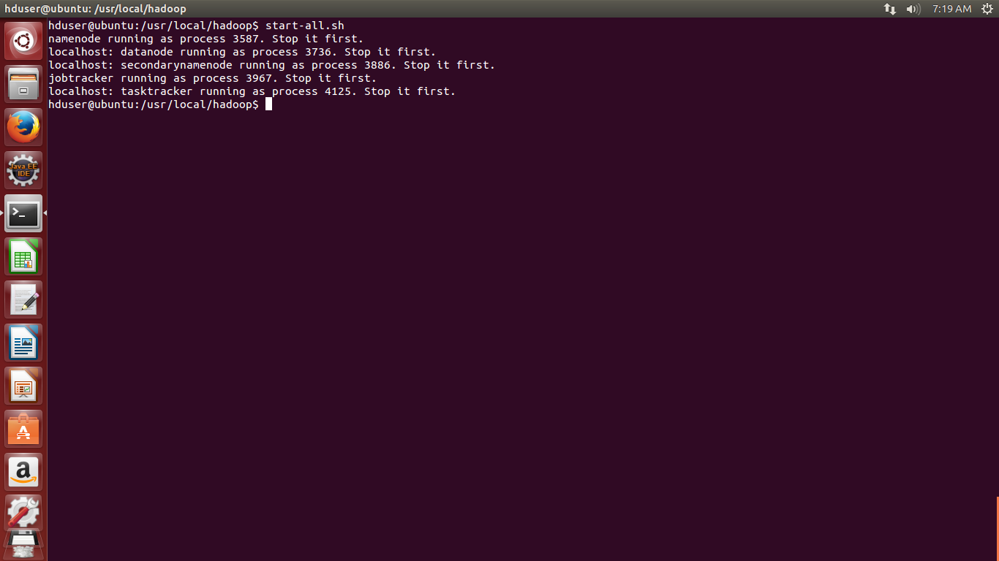

The start-all.sh command starts all the Hadoop services required for the MapReduce process. This command activates both the start-dfs.sh and start-mapred.sh commands too.

Step 2: Check if all the nodes are working as per requirement

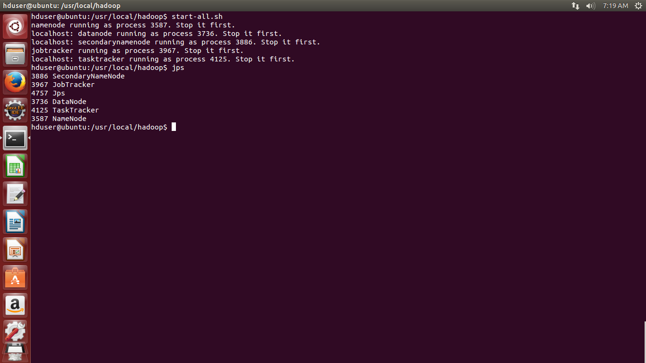

The JPS command is used to track all the namenodes, datanodes, job trackers,secondary namenodes and task tracker in all the systems. This command is used to check if all the nodes are working properly or not.If there is a malfunction in the configuration of theses nodes, they can be detected using JPS

Step 3: Run the MapReduce program using Hadoop

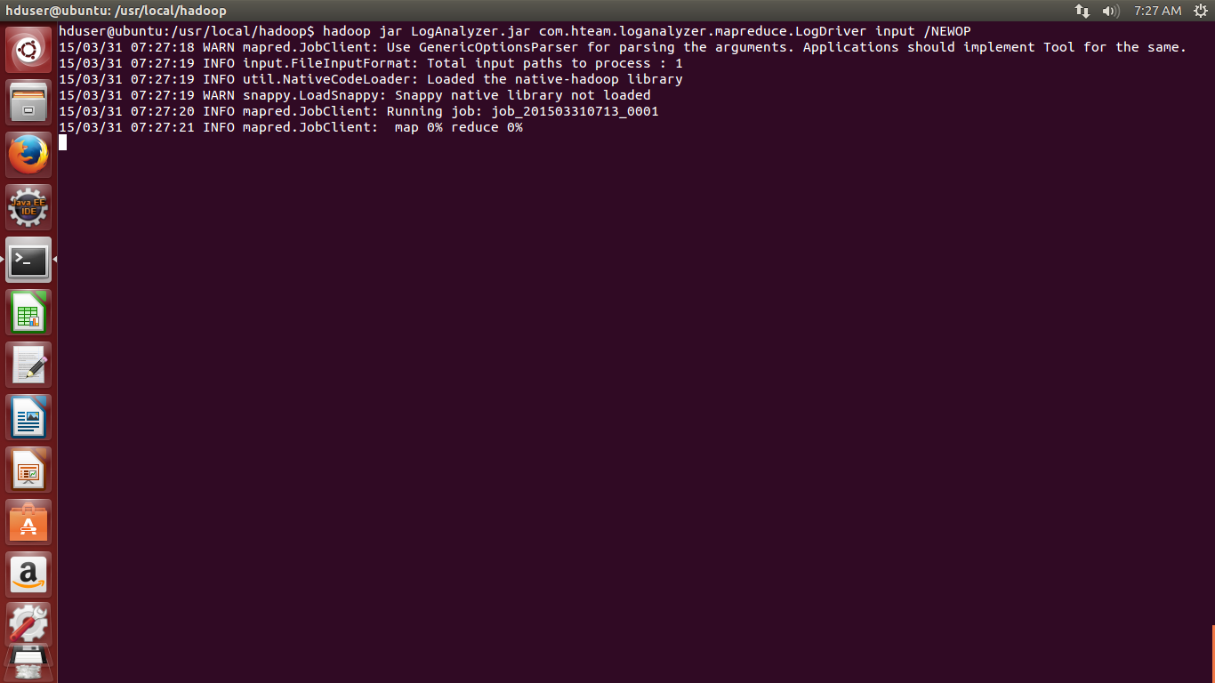

The “hadoop jar <file pathname> <input folder> <output folder>” command is executed to initiate the MapReduce process on the log file to start the Mapping and Reducing process.

Step 4: Visualization of Data
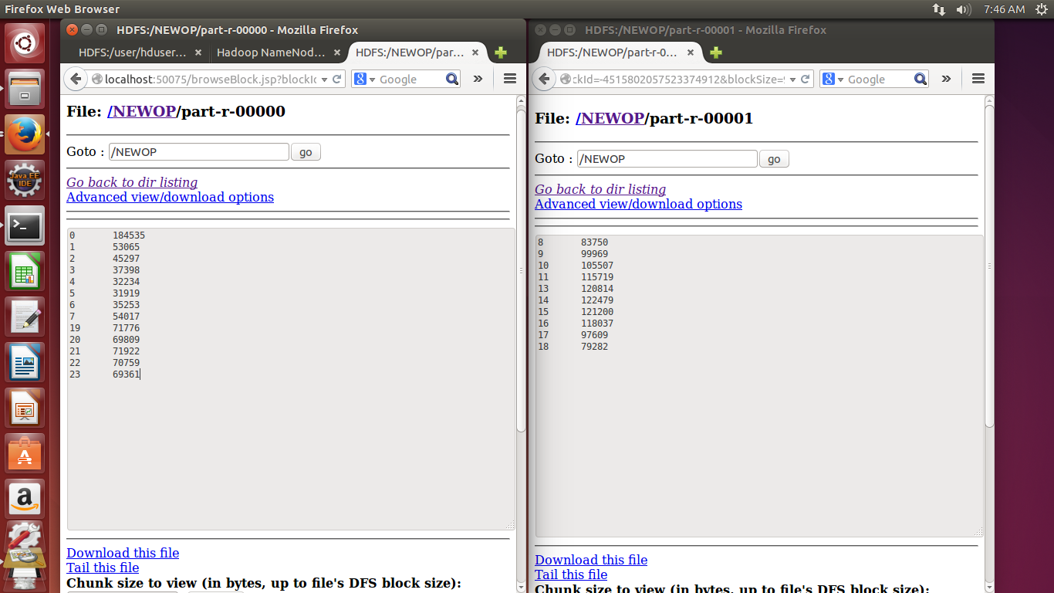

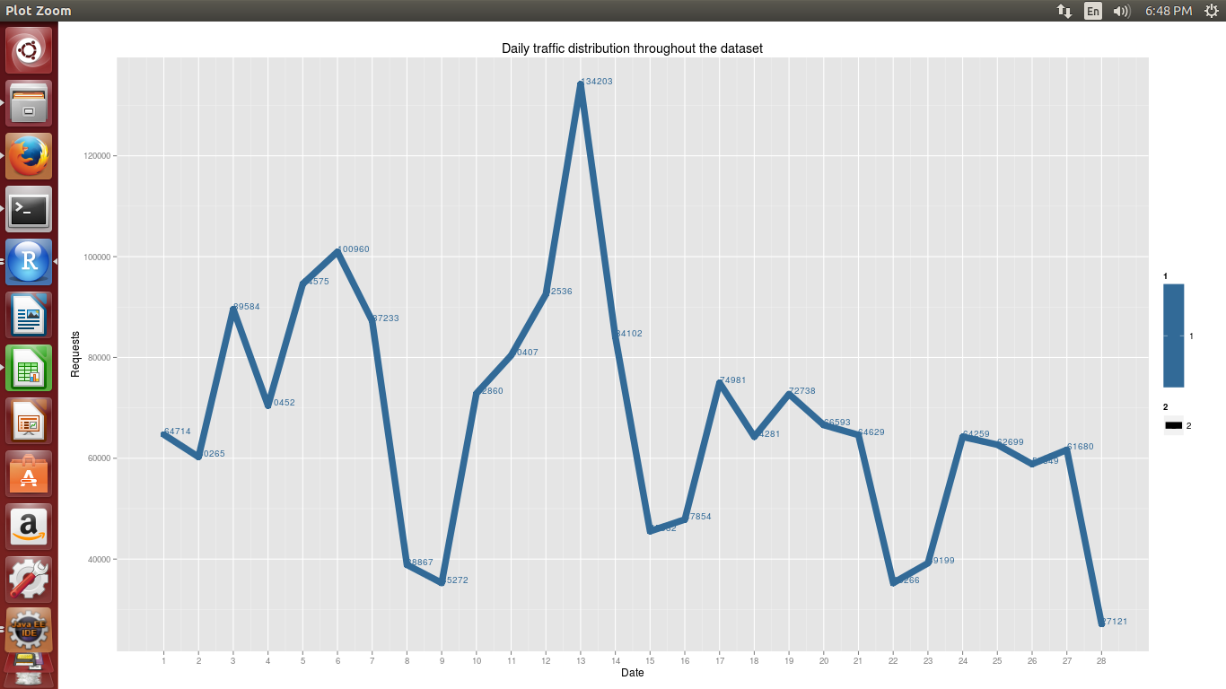

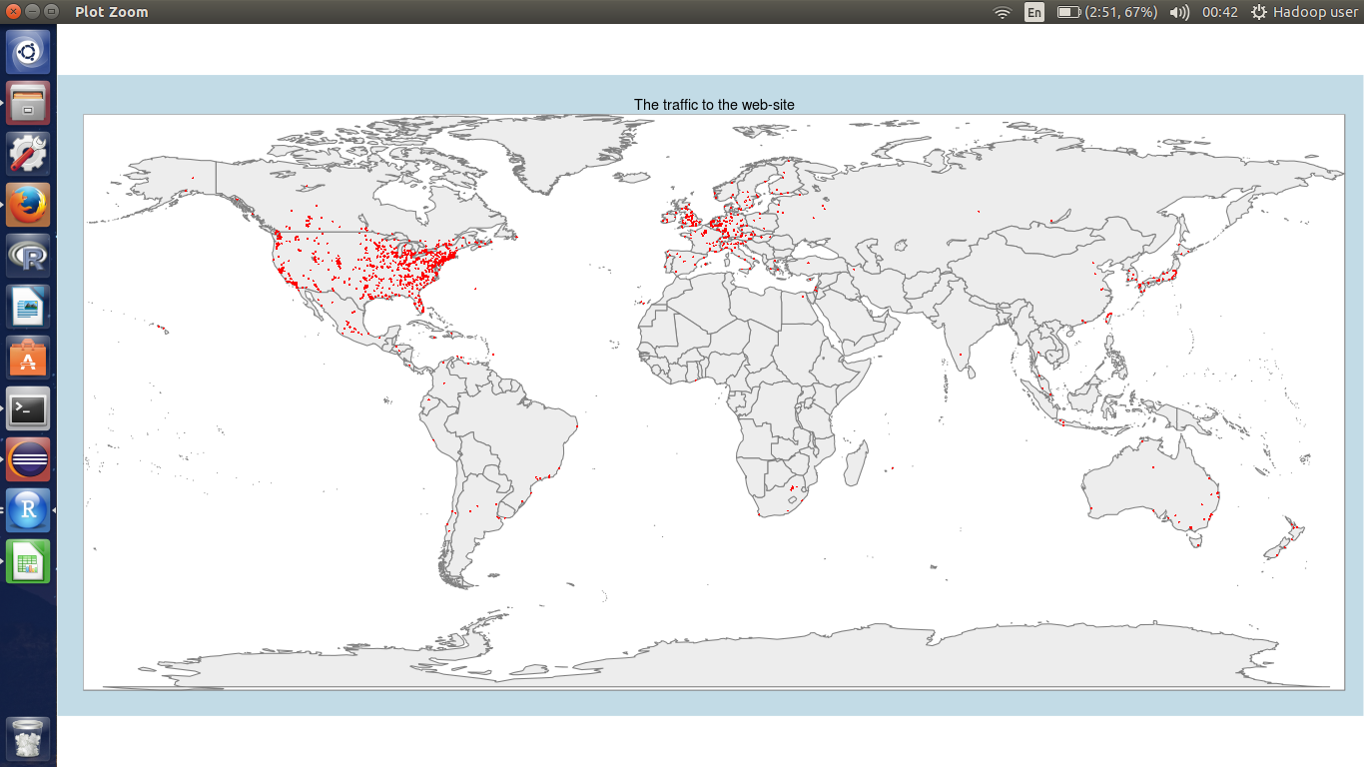

The resulted data can be visualized using the R language based “R Studio”. This tool can be used to produce the data in various graphical representations like Line graph and Bar graph. It can also be used to plot the data on the map to visualize the locations from where the request to the server were made.

